**Solar Power Forecasting using Deep Learning**

**Renewable Energy Project**

### Submitted by:

**Arpit Mathur (9915103112) Ravi Gaurav (9915103128)**

**Gaurav Singh (9915103252)**

Under the supervision of:

**Vinay Tikkiwal**



**Jaypee Institute of Information Technology University, Noida**

**Semester VI, 2018**

# **ACKNOWLEDGEMENT**

The completion of any inter-disciplinary project depends upon cooperation, co-ordination and combined efforts of several sources of knowledge. We are grateful to Dr. Vinay Tikkiwal for his even willingness to give us valuable advice and direction whenever we approached him with a problem. We are thankful to him for providing us with immense guidance for this project.

We are also thankful Vinay Tikkiwal sir for giving his valuable time for evaluating our project. We would also like to thank our College authorities and Head/Dean for giving us the opportunity to pursue our project in this field and helping us to successfully complete this project.

**Signature:**

**Names:**

Arpit Mathur (9915103112) – F4

Ravi Gaurav (9915103128) – F4

Gaurav Singh (9915103252) – F8

1. **PROBLEM STATEMENT: -**

Power forecasting of renewable energy power plants is a very active research ﬁeld, as reliable information about the future power generation allow for a safe operation of the power grid and helps to minimize the operational costs of these energy sources. Deep Learning algorithms have shown to be very powerful in forecasting tasks, such as economic time series or speech recognition. Up to now, Deep Learning algorithms have only been applied sparsely for forecasting renewable energy power plants. By using different Deep Learning and Artiﬁcial Neural Network Algorithms, such as Auto Encoder and LSTM, we introduce these powerful algorithms in the ﬁeld of renewable energy power forecasting. Our motive is to show the forecast strength of these algorithms compared to a standard MLP and a physical forecasting model in the forecasting the energy output of 21 solar power plants and compare our results with results obtained from Artiﬁcial Neural Networks as well as other reference models such as physical models.

1. **DATASET EXPLAINED: -**

The GermanSolarFarm data set contains 21 photovoltaic facilities in Germany. Their installed nominal power ranges between 100kW and 8500kW. The PV facilities range from PV panels installed on rooftops to fully fledged solar farms. They are distributed throughout Germany as shown in the attached image. For each facility historical NWP data and the produced power in a three-hour resolution for 990 days are available. All-time series in the data set, except the measured power output, are normalized between 0 and 1 using the minmax normalization. The target variable, the measured power output, is normalized using the nominal output capacity of the corresponding PV facility. Therefore, allow the comparison of the forecasting performance without taking the size of the PV facilities into account. The data can be downloaded at

[*http://ies-research.de/Software*](http://ies-research.de/Software)*.*

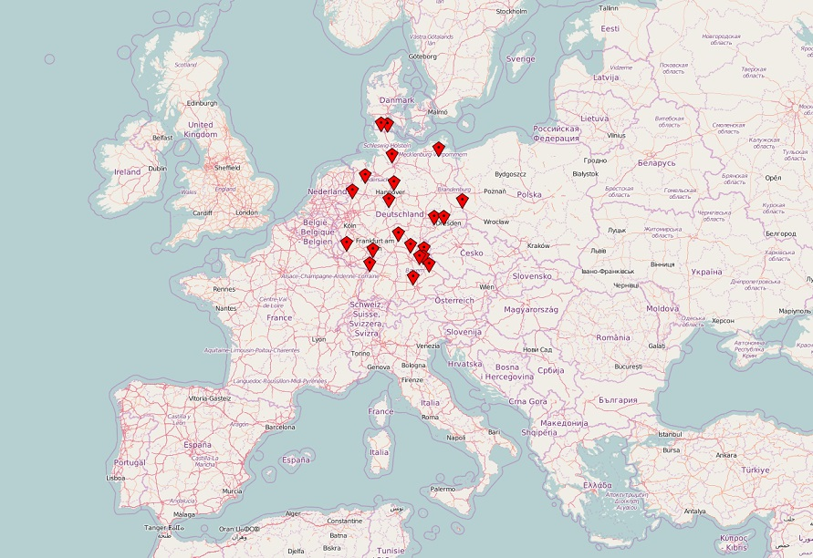

1. **TECHNIQUES AND ALGORITHMS USED: -**
   1. *PCA (Principle Component Analysis): -*

Principal Component Analysis (PCA) is a dimension-reduction tool that can be used to reduce a large set of variables to a small set that still contains most of the information in the large set.

The first principal component accounts for as much of the variability in the data as possible, and each succeeding component accounts for as much of the remaining variability as possible.

* 1. *LSTM (Long Short-Term Memory): -*

The Long Short-Term Memory networks (LSTM) are based on Recurrent Neural Networks (RNN). An LSTM has a special neuron structure called memory cell. These memory cells have the ability to store information over an arbitrary time. Three gates control the information ﬂow into and out of the neuron’s memory cell: the input, output, and forget gate. Each gate in the LSTM gets the same input as the input neuron. Furthermore, each gate possesses an activation function. The main difference in training an LSTM in contrast to an MLP is, that to predict a value pt at time t, the previous n samples {pt−n,...,pt−1} have to be propagated through the net. This settling time n has to be deﬁned while setting up the network. The memory cells will store the temporal information according to their training status and deliver the predicted output pt.

* 1. *Libraries Used: -*

1. Scikit-Learn
2. Keras
3. Pandas
4. Matplotlib
5. PVlib
6. Itertools
7. Numpy
8. **IMPLEMENTATION: -**
9. **RESULTS: -**
10. **EVALUTATION AND COMPARISON: -**
11. **CONCLUSION: -**
12. **REFERENCES: -**
13. Gensler, A., Henze, J., Sick, B., & Raabe, N. (2016, October). Deep Learning for solar power forecasting—An approach using AutoEncoder and LSTM Neural Networks. In Systems, Man, and Cybernetics (SMC), 2016 IEEE International Conference on (pp. 002858-002865). IEEE.
14. Reno, M. J., Hansen, C. W., & Stein, J. S. (2012). Global horizontal irradiance clear sky models: Implementation and analysis. SANDIA report SAND2012-2389.